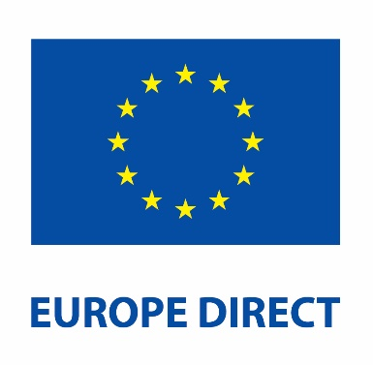
Europe Direct Soapbox Competition

Application Form
‘Culture is at the heart of what it means to be European. But is Ireland culturally closer to Strasbourg or Sydney?’

3 minutes to have your say!

How to apply
Submit the form by email to your local Europe Direct. Contact details are available at www.europedirect.ie.

Application Form
Name of Europe Direct: _________________________________

Category: ☐ 16 & under ☐ 17 & over

Name: ______________________________________________________________

Age (if entering 16 & under category): ____________________________________

Address: ____________________________________________________________

Contact Telephone Number: ____________________________________________

Email: _______________________________________________________________

Applicant, please read and sign below:
I have read the rules regarding the soapbox events and agree to abide by them.

Signature of applicant: ________________________________________________
Date: ______________________________________________________________

