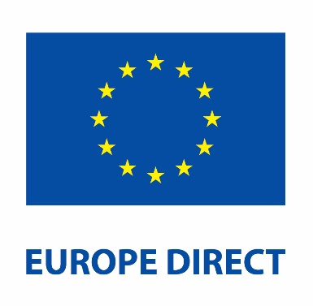
Europe Direct Soapbox Competition

Application Form
Lies, damned lies and statistics
– establishing the truth is impossible in today’s world of misinformation, disinformation and propaganda.

How to apply
Submit the form by email to your local Europe Direct. Contact details are available at www.europedirect.ie.

Application Form
Europe Direct: _________________________________

Category: ☐ 16 & under ☐ 17 & over

Name: ______________________________________________________________

Age (if entering 16 & under category): ____________________________________

Address: ____________________________________________________________

Contact Telephone Number: ____________________________________________

Email: _______________________________________________________________

Applicant, please read and sign below:
I have read the rules regarding the soapbox events and agree to abide by them.

Signature of applicant: ________________________________________________
Date: ______________________________________________________________

Parent/ guardian, please read and sign below (for applicants under the age of 16):
Each EDIC will run an online event where the regional winning video entries are played. All regional winning video entries will then be played in a separate online national event in December. Please sign below to consent to your child taking part in the competition and your child’s video entry being played during both of these events.

Parent/ guardian signature: _____________________________________

Date: _____________________________________________

