Library Treasure Trail - Part 1
- Can you borrow hens, books or shoes from the library?
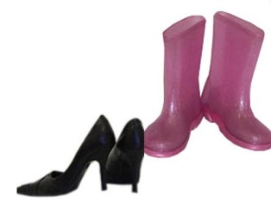
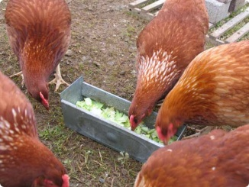
Tick the correct box.

Hens Books Shoes

- To borrow books in the library, you need to bring your
golden ticket lunch box library card

- If you need help finding a book, who should you ask in the library ?
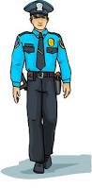
Librarian Garda Doctor
- Think of something new you’d like to know about the library.
Your question:
___________________________________________________________
Find a librarian and ask!

Answer to your question:
___________________________________________________________

___________________________________________________________

- If I had 6 books borrowed from the library and I returned 2 books,
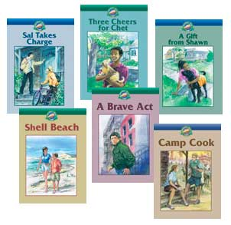
how many books do I now have?
Answer: _________________

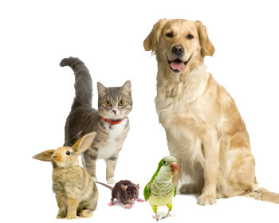

- Name your favourite animal.
________________________________
How many information books about your favourite animal can you find in the library?
Answer: _________________
- Find a book about bears in the library.
What is it called?
________________________________________________

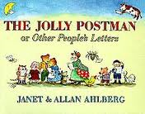
- Go to the library catalogue on a computer and find the book The Jolly Postman.

How many copies of this book are there? _________________

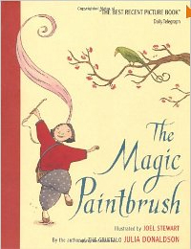
- Find the book The Magic Paintbrush.

Write down the name of the author of this book.
____________________________________________________

