Library Treasure Trail - Part 1
Completed individually, in a group or with help from a librarian
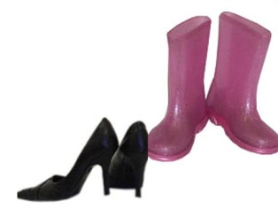
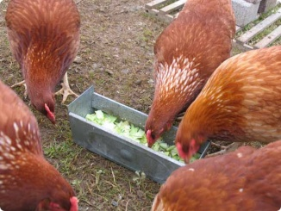
- What can you borrow from the library?

Hens Books Shoes

- Who can help you in the library?
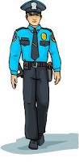
Librarian Garda Doctor

- Find a librarian!
Ask the librarian to tick the box.

- How many librarians are there in the library?

Answer: _________

- Draw your favourite animal.

- Find a book with a picture of your favourite animal in it.
My favourite animal book is called:
_________________________________________________
_________________________________________________

