Library Treasure Trail - Part 2

- Name your favourite book in the library.
__________________________________________________________
__________________________________________________________

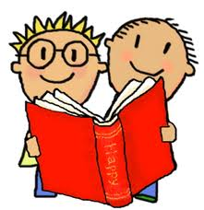
- Pick a book which has some new words you’ve never seen before.
Take turns with your library partner to read every second sentence on the first page!

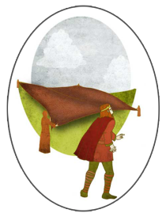
- On the website www.askaboutireland.ie,
listen to the story St. Brigid’s Cloak.
After listening, answer the following question:
In what part of Ireland did St. Brigid build her monastery?
_______________________________________________

- Find a new book you really like in the library.
Hold it in the air and jump up and down five times!

- Find out the times that the library opens on Thursdays.
Write them down below.
_______________________________________________________
_______________________________________________________

- Find a book of rhymes.

Read a rhyme out loud with your library partner
while standing on one foot!

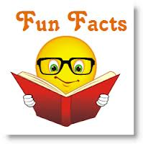
- Find a book of facts.
Look inside for a new fact.
Learn it by heart and then tell it to your library partner!

