Library Treasure Trail - Part 2
Completed individually, in a group or with help from a librarian

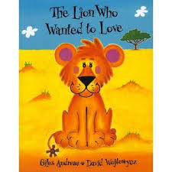
- Find the book The Lion Who Wanted to Love.
What colour are the lion’s ears?
_______________________________________

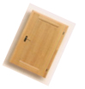
- How many doors are there in the library?
Answer: _________

- Find one of your favourite books in the library.
Hold it in the air and jump up and down five times!

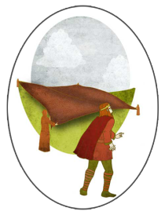
- Go to a computer and listen to the story of
St. Brigid’s Cloak.
What colour is St. Brigid’s cloak in the story?
______________________________

- Find a new book you would like to read.
Read the first page with your library partner.

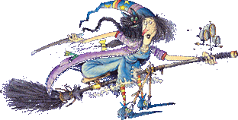
- Where is the book Winnie the Witch hiding?
______________________________

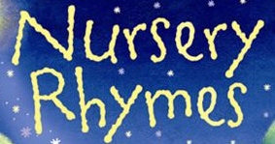
- Find a book of rhymes.
Read a rhyme out load while standing on one foot!

